**Lab Submission**

**Instructor: Basit Ali**

**Assignment-02**

1. Create a (Yourname).txt file in Cent OS  
   2. Write some information in that particular file.  
   3. Create a directory of your name in Hadoop File System.

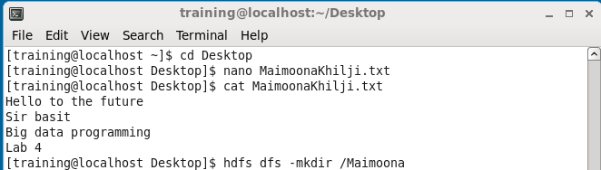

4. Copy (Yourname).txt file from your Cent OS to Hadoop Environment.  
5. List the directory.

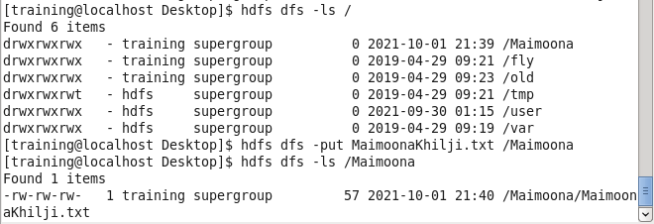

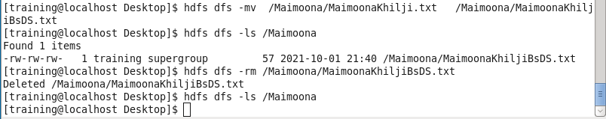  
6. Rename (Yourname).txt file to (Yourname+BSDS).txt  
7. List the directory Attach Screenshot in Word Document.  
8. Write command to remove that (Yourname+BSDS).txt file.

**---------------------------------------------**